**Ideation Phase**

**Empathize & Discover**

|  |  |
| --- | --- |
| Date | 31 January 2025 |
| Team ID | SWTID1745000177 |
| Project Name | ShopEZ – A Seamless Online Shopping Platform |
| Maximum Marks | 4 Marks |

**Empathy Map Canvas:**

Empathy Map for Sarah (Buyer)

**1. Says**

* “I just want to find the perfect gift quickly.”
* “There are too many options online!”
* “I don’t have time to browse endlessly.”

**2. Thinks**

* “What if I don’t find something in time?”
* “Will she even like this gift?”
* “I wish shopping online was simpler.”

**3. Does**

* Searches for products by category
* Reads reviews and filters by price
* Adds items to cart and compares

**4. Feels**

* Stressed due to time constraints
* Anxious about making the wrong choice
* Relieved when checkout is smooth and confirmation is received

**Pain Points:**

* Overwhelming number of options
* Inconsistent shopping interfaces
* Time crunch

**Goals:**

* Quickly discover relevant products
* Enjoy personalized shopping
* Complete orders securely and confidently

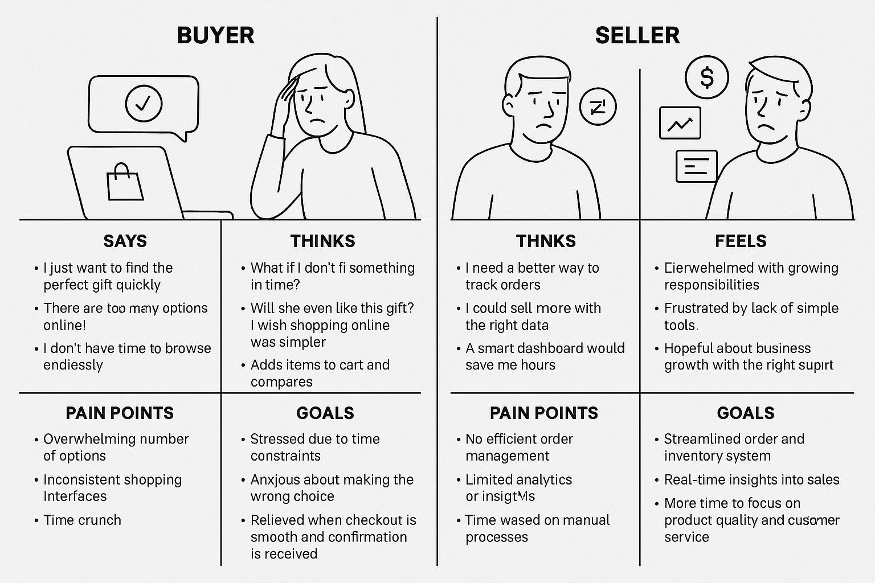

**Example: Food Ordering & Delivery Application**

Empathy Map for Seller

